**Benchmarking: Hart House**

Hart House is a student-focused center that houses many different expressions of student arts, wellness, and dialogue. Hart House allows unique ways for students, faculty, alumni and the broader community to connect and engage with one another. The facility includes a wide range of rooms for studying, dining, recreation,and socializing.

Despite their being small meeting rooms in Hart House, they are designed in a way that fosters community between students, creating a lively environment.

*Table 1: Pros and Cons of Hart House*

| Pros | Cons |
| --- | --- |
| * has many different rooms and allows for a wide variety of student groups to meet and collaborate * Room sizes vary allowing for small meeting and studying rooms (5-10) and large rooms that allow for 30-50 people * Allow for storage of different materials like sporting equipment, food, instruments, books, etc. | * the building is slightly disorganized which can allow for clutter with no systematic process of where things need to be placed * there is not overall community within Hart House and more separate small communities that come in and out each day * It can be difficult to navigate Hart House and understand where everything is and where certain rooms with specific functions are. |

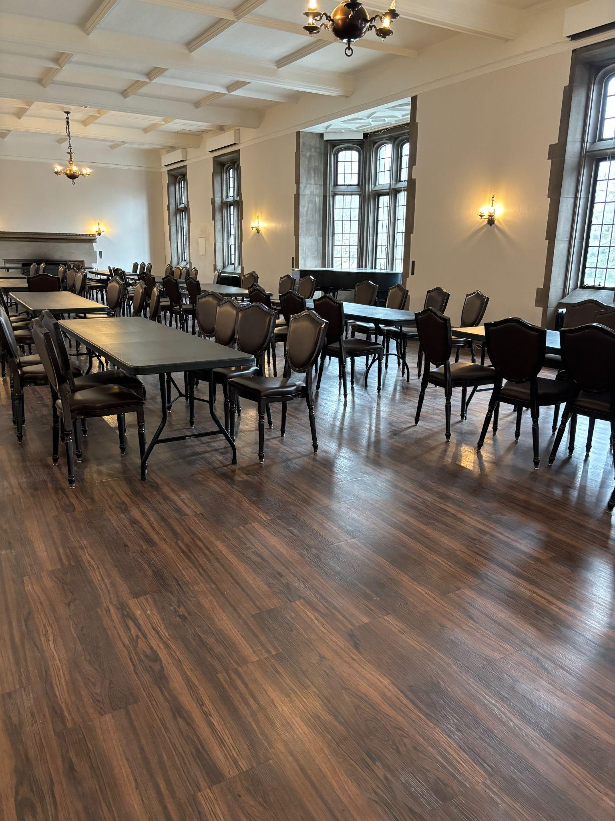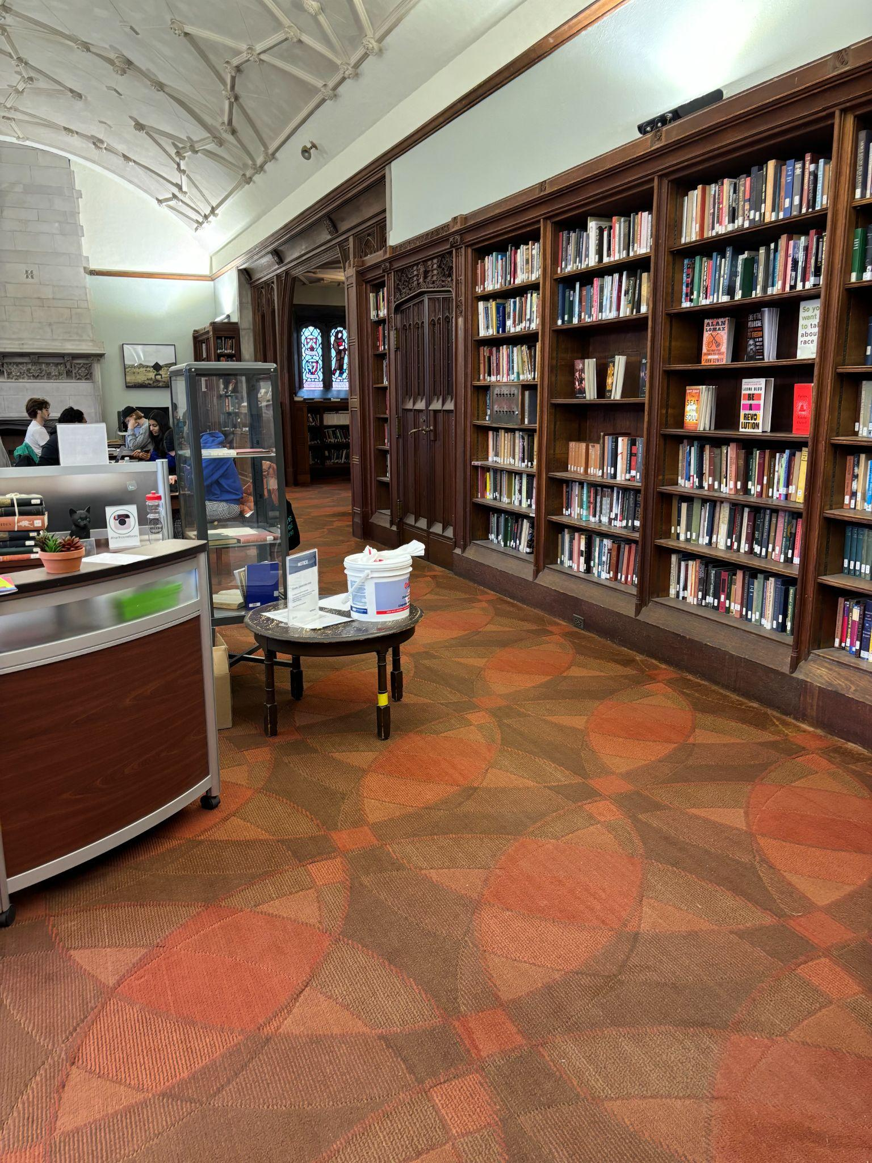

*Table 2: Space Objectives of Hart House*

| Space Objectives | Description |
| --- | --- |
| Maximize utilization of the space | Various spaces within Hart House hold student gatherings to foster community, collaboration and creativity. The goal is to have a building that brings people together. Rooms are organized, creating space for students and faculty to gather properly without having any obstacles such as misplaced items, etc. |
| Universal Usage of Furniture | Hart house utilizes many different furniture options, making it easy to cater a room to your needs. They have foldable chairs and tables as well as chairs and tables with wheels that can move to however the user likes. |

*Table 3: Storage Objectives of Hart House*

| Storage Objectives | Description |
| --- | --- |
| Secure | Hart House has storage cabinets that are locked up so no one without a key can access what's inside. |
| Durable and robust | Hart House has storage for all different types of materials, such as sports equipment, books, important documents, and even food. They are equipped to store all different types of materials well. |

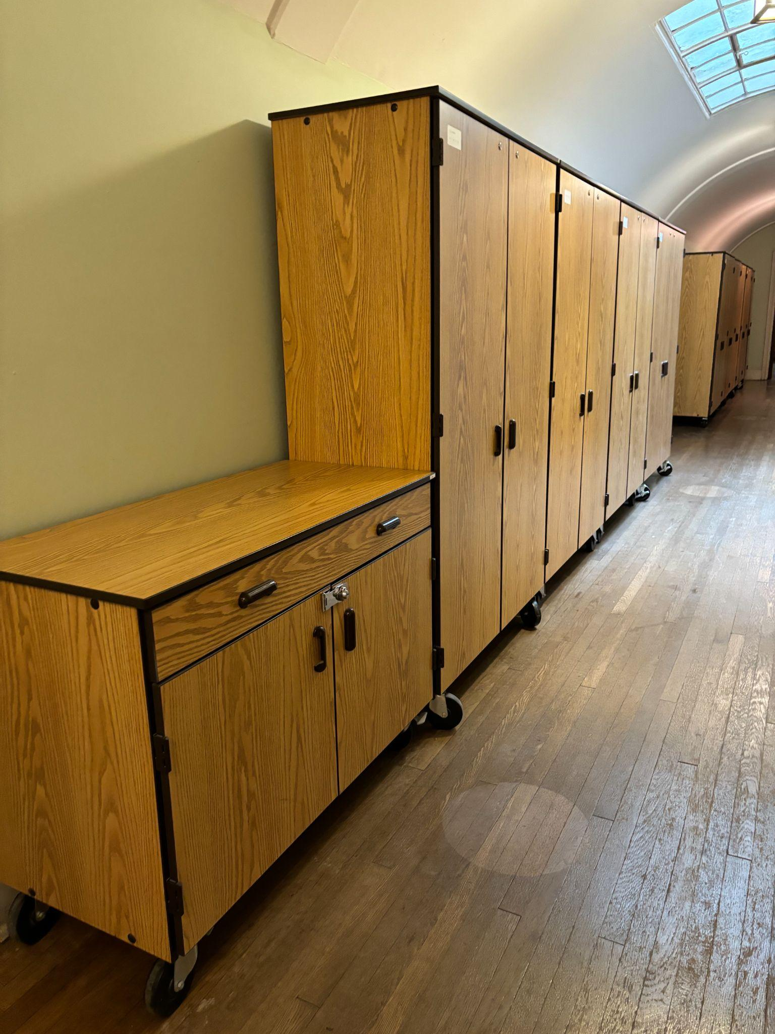

Function: Provide free meeting and work spaces for clubs and the staff of the University of Toronto and bring more students into the clubhouse and construct a more lively space.

*Table 4*

| Form | Flow |
| --- | --- |
| The Hart House meeting rooms, despite their size, provide an efficient and lively space for students to meet and socialize. Some rooms are large rooms for meetings while some are smaller. Hart House is equipped with various types of storage units. | Mass: UofT Students and Staff in and out. Items in and out of storage units.  Energy: Lighting  Information: Student/staff meetings |
| Analysis: There are durable and spacious storage units in place as shown in Figure 2. They are portable since they are equipped with wheels. The storage units are sturdy as they are made of wood. The units are spacious and can store a significant amount of items. | |

Hart House is an excellent example of the environment the client wants to recreate at the Clubhouse. A friendly environment that fosters collaboration, creativity, and group work through the utilization of large meeting spaces with adequate storage, as well as smaller meeting rooms for more intimate meetings. Hart House has many different types of storage units as well, and there is always somewhere to gather people, be on your own, or store important material.